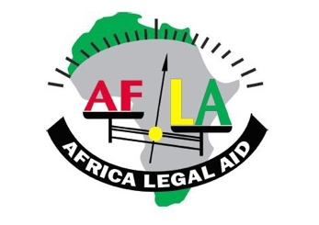
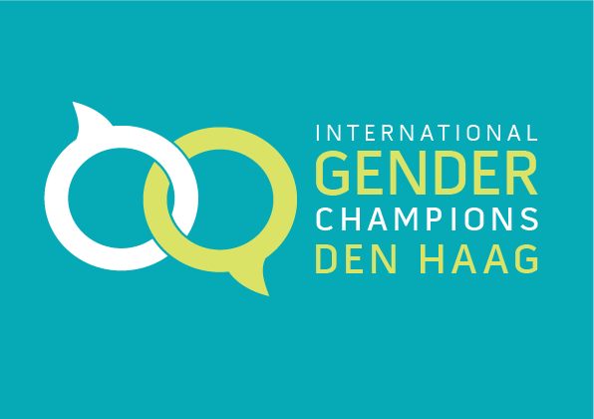

P R O G R A M M E
AFLA-ASP Side Event

Gender Diversity and the Rome Statute System (co-hosted by Australia, Uganda, International Gender Champions Den Haag and Africa Legal Aid (AFLA))
13:15 – 14:45 CET…..………………………………….…………Oceania
Simultaneous Interpretation in French and English

Evelyn A. Ankumah
Executive Director, Africa Legal Aid (AFLA); Coordinator, Gender Mentoring Training Programme for Judges
Chair

Judge Piotr Hofmanski
President of the International Criminal Court
The Importance of Gender Diversity in International Criminal Law

Judge Solomy Balungi Bossa
Appeals Chamber, International Criminal Court (ICC); Chairperson, Gender Mentoring Training Programme for Judges
International Criminal Justice through a Gender-Sensitive Lens

Judge Fatoumata Dembele Diarra
Former Judge and First Vice President, International Criminal Court (ICC)
Interpreting Crimes to Ensure the Protection of all Gender Identities and Sexual Orientations

Jennifer Naouri
Immediate Past President, International Criminal Court Bar Association (ICCBA)
The Principle of Complementarity and Gender Diversity

Alix Vuillemin
Advocacy Director, Women’s Initiatives for Gender Justice
Applicability of Gender-related Provisions of the Rome Statute to Gender Diversity

Julie Heckscher
Head of Mission, Australia Embassy, The Hague
Concluding Remarks on the Protection of Gender Diversity

FLOOR DISCUSSION

Join the side event virtually: https://us06web.zoom.us/j/83845345968

